Reports of inspection of Weather station at Rulindo, Gicumbi and Burera District
- INTRODUCTION
These reports present the findings from the inspection of the Manual Rain Gauge, Climatology Station, Automatic Rain Gauge, and Automatic Weather Station carried out in Rulindo, Gicumbi, and Burera districts from November 9th to 14th, 2025.
During the inspection, the following activities were conducted: visiting stations to assess whether they are situated in suitable environments and taking corrective actions where necessary, collecting data forms from manual stations, identifying technical issues, and performing preventive maintenance on automatic weather stations.
- FINDINGS AND RECCOMENDATIONS
  - ISSUES ON MANNAUL STATIONS
STATION | FINDINGS | RECOMMENDATIONS
RUTONGO MRG | The station is located near tall grasses and surrounded by several obstacles. Additionally, the water collector installed is an outdated model of measuring cylinder of 8 mm. | Relocate the station to an open area and replace the existing collector with a new 10 mm measuring cylinder model.
BURATO MRG | The hook support used to hold the rain collector is damaged. | Replace the rain gauge support
MULINDI CLIMATIC | Old versioned of hgyro-thermometer | Replace the hgyro-thermometer.
KAGOGO CLIMATIC | The fence wires are completely missing. | Rehabilitation of the fence.
NTARUKA CLIMATIC | Two tubes near the fence gate are broken. | Replace the two broken tubes. And providing water proof padlock.
MURAMBI/MUGAMBAZI  CLIMATIC | The wires on the fence and foundation were partially damaged. | Replace the damaged wires and rehabilitate the foundation.
CYINZUZI CLIMATIC | Rusted fence | To paint the fence
RUHUNDE CLIMATIC | Rusted fence | To paint the fence
GICUMBI Agro-synoptic | Painting the Stevenson screen and fence and rehabilitate the foundation, installation of soil thermometers at depth of 10 Cm and 20 Cm and installing the evaporation pan.
  - OTHER OBSERVATIONS ON MANUAL STATIONS
- Stevenson screens on all sites need to painted.
- No issues found at NYAMIYAGA, KINONI and RWESERO Rainfall stations.
  - ISUUES ON AUTOMATIC WEATHER STATIONS
STATION | FINDINGS | RECOMMENDATIONS
CYANIKA BOARDER AWS | During the visit the data logger was off which implies the malfunctioning of the battery. | To replace the battery.
KINONI ARG | Water collector was blocked the water do pass from the water filter. | To replace water collector.
RWERERE ARG | The water collector was blocked, preventing water from passing through the filter. The fence tubes and foundation were also damaged. | Repair the damaged fence tubes and foundation and replace water collector.
CYERU AWS | Fence’s wires and foundation are partially damaged. | Repair the damaged fence tubes and foundation.
CYUMBA ARG | The station had no battery. During inspection, a battery was supplied; however, it was not new and failed to operate. | Replace the battery with a new, fully functional one.
BYUMBA AWS | Station does not report/troubleshooting was made but resist. | Further investigation of data logger communication protocal.
CYINZUZI ARG | There is trees near station | Relocate the station to same fence of CYINZUZI Climatic station.
  - OTHER OBSERVATION ON AUTOMATIC WEATHER STATION
- The instruments at Cyeru, Bungwe, and Cyanika border automatic weather stations were very dirty and have been cleaned; regular maintenance is recommended to ensure their proper functioning.
- The security officer at the Automatic Weather Station emphasized the need for a shelter room.

- ANNEX
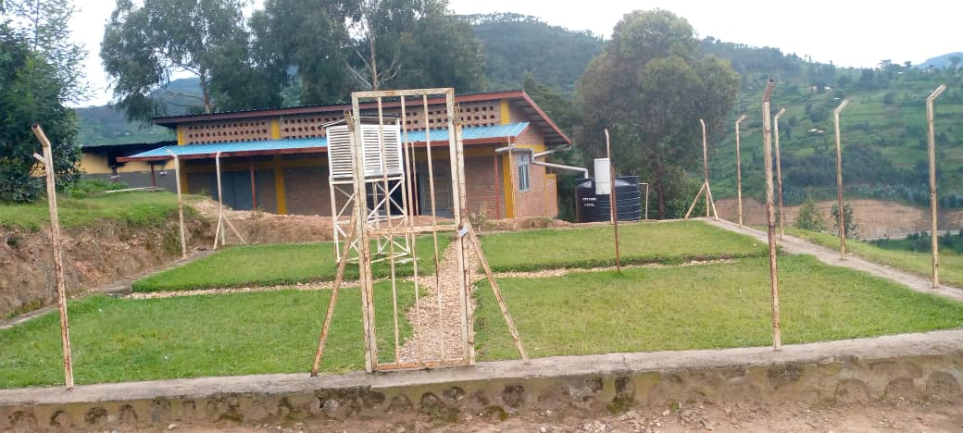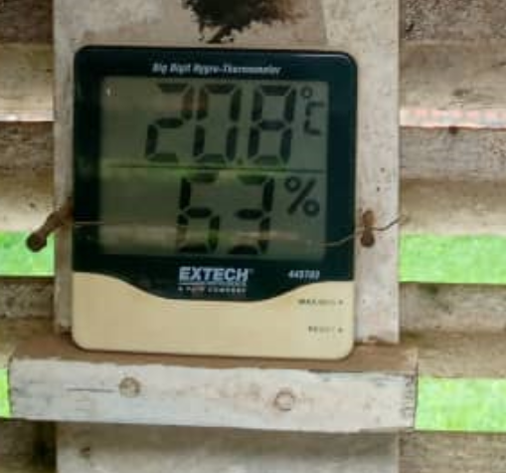
Figure 1:KAGOGO CLIMATIC Figure 2:MULINDI CLIMATIC
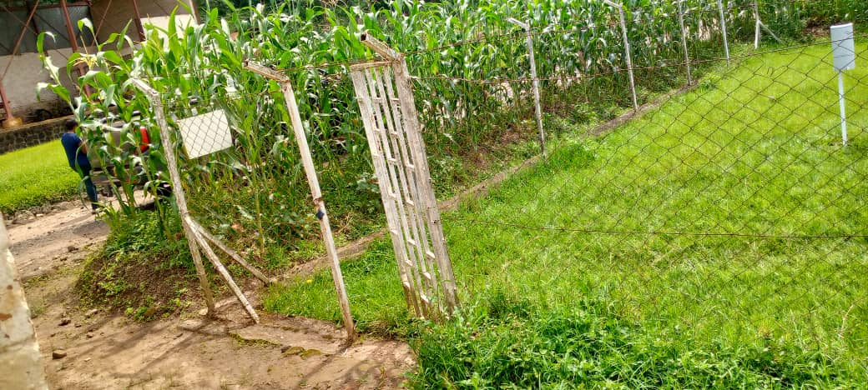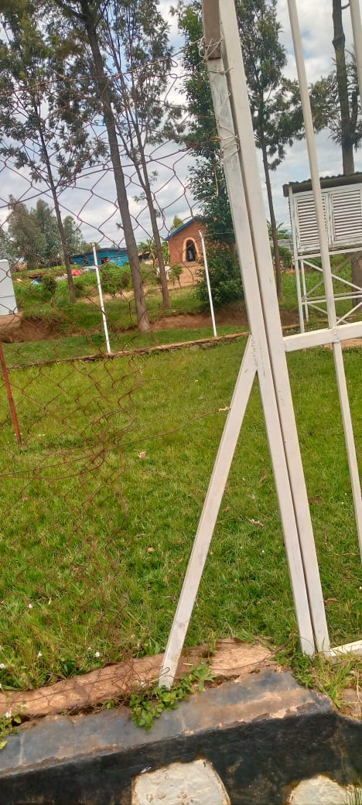
Figure 3:NTARUKA Site Figure 4:MUGAMBAZI Climatology station

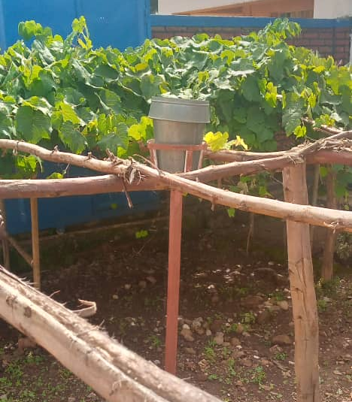
Figure 5: RUTONGO Manual Rain gauge

Prepared by

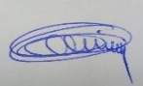
INGABIRE Dianne BIKORIMANA CHRISTIAN MUREMBWAYIRE U Macrine
Observation Officer Ag.Data Quality Control Officer Observation Officer

